Collin Gamble
PRO390 – Capstone Project
Week 8: OWASP ZAP Automated Security Validation
Degree: Information Systems & Cybersecurity
Date: February 25th, 2026

Table of Contents
1. Introduction 3
2. Testing Methodology 3
3. Initial Scan Results 4
3.1 Medium-Risk Findings 4
3.2 Informational Findings 5
4. Security Hardening and Revalidation 5
5. Validation of Previously Exploited Vulnerabilities 6
6. Security Posture Comparison 6
7. Conclusion 7

1. Introduction
The purpose of Week 8 was to conduct automated security validation of the remediated Capstone web application using OWASP ZAP (Zed Attack Proxy). Following the intentional vulnerability implementation (Week 4), controlled exploitation (Week 5), and remediation phase (Week 6), this phase focused on verifying that previously exploitable vulnerabilities were no longer detectable through automated scanning.
Testing was conducted locally against http://localhost:3000. The application was not exposed to the internet, and no real user data was used. The objective was to validate the effectiveness of implemented security controls and identify any remaining configuration weaknesses.

2. Testing Methodology
Tool Used:
OWASP ZAP 2.17.0 (Desktop Version)
Environment:
- Node.js / Express backend
- MongoDB database
- Helmet security headers enabled
- CSRF protection enabled
- express-rate-limit implemented
- express-mongo-sanitize implemented
- Hardened session configuration (HttpOnly, SameSite)
Testing Process:
- Configured OWASP ZAP to scan the local application.
- Executed automated spidering to discover routes.
- Performed both passive and active scanning.
- Reviewed all generated alerts.
- Hardened Content Security Policy configuration.
- Re-ran automated scan to validate improvements.

3. Initial Scan Results
The initial automated scan after remediation produced:
- High Risk Alerts: 0
- Medium Risk Alerts: 3
- Low Risk Alerts: 0
- Informational Alerts: 3
No injection vulnerabilities, XSS issues, authentication bypasses, or CSRF bypasses were detected.
Figure 1 – Initial OWASP ZAP Alert Summary
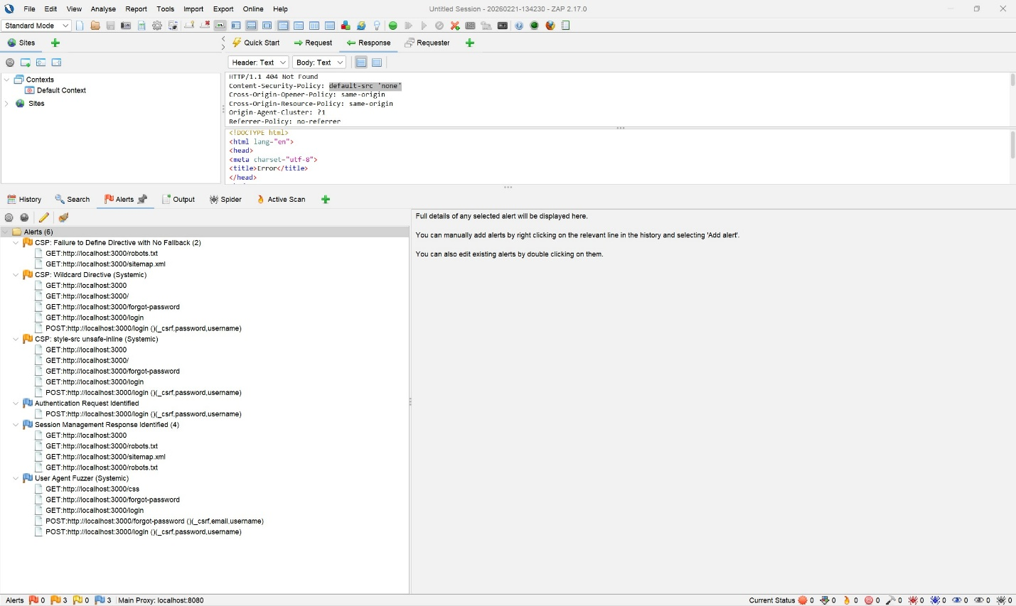
This screenshot shows the overall alert distribution from the first automated scan.

3.1 Medium-Risk Findings
The scan identified three Content Security Policy-related recommendations:
- CSP: Failure to Define Directive with No Fallback
- CSP: Wildcard Directive (Systemic)
- CSP: style-src 'unsafe-inline'
Figure 2 – CSP: Failure to Define Directive with No Fallback
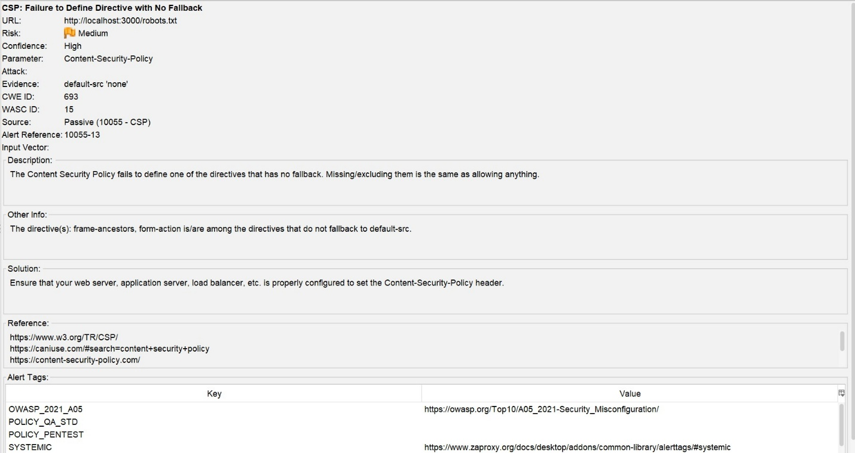
Figure 3 – CSP: Wildcard Directive (Systemic)
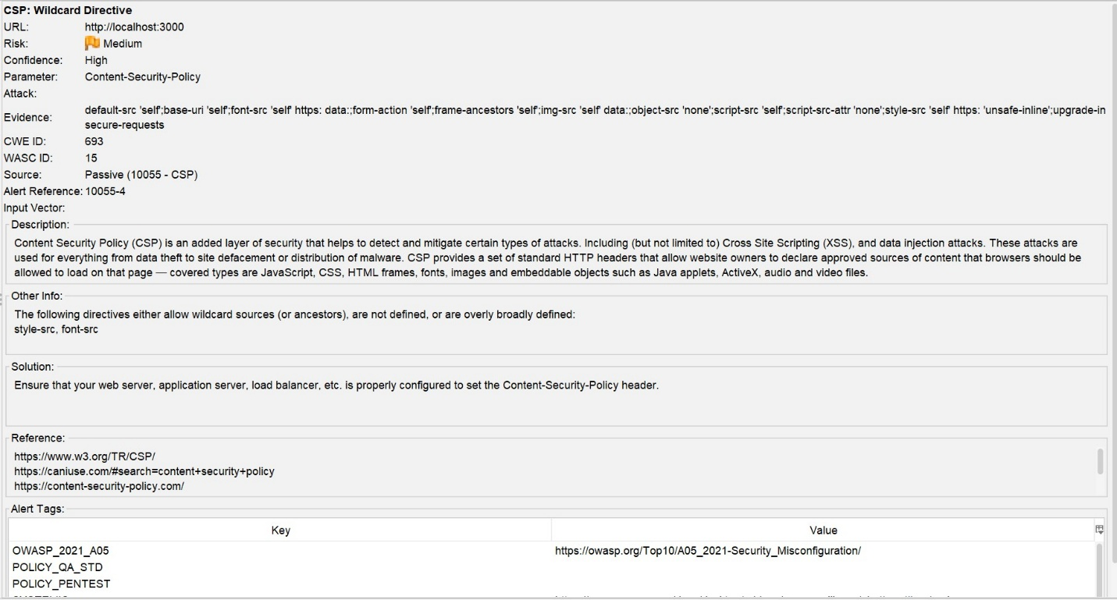
Figure 4 – CSP: style-src 'unsafe-inline'
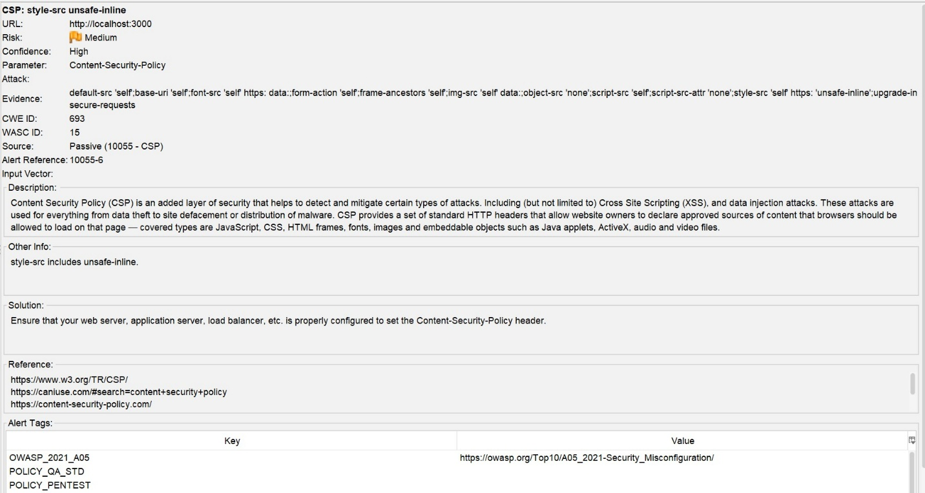
These findings did not represent exploitable vulnerabilities but indicated opportunities to further harden the application’s Content Security Policy configuration.

3.2 Informational Findings
The scan also identified informational-level alerts:
- Authentication Request Identified
- Session Management Response Identified
- User Agent Fuzzer
Figure 5 – Authentication Request Identified
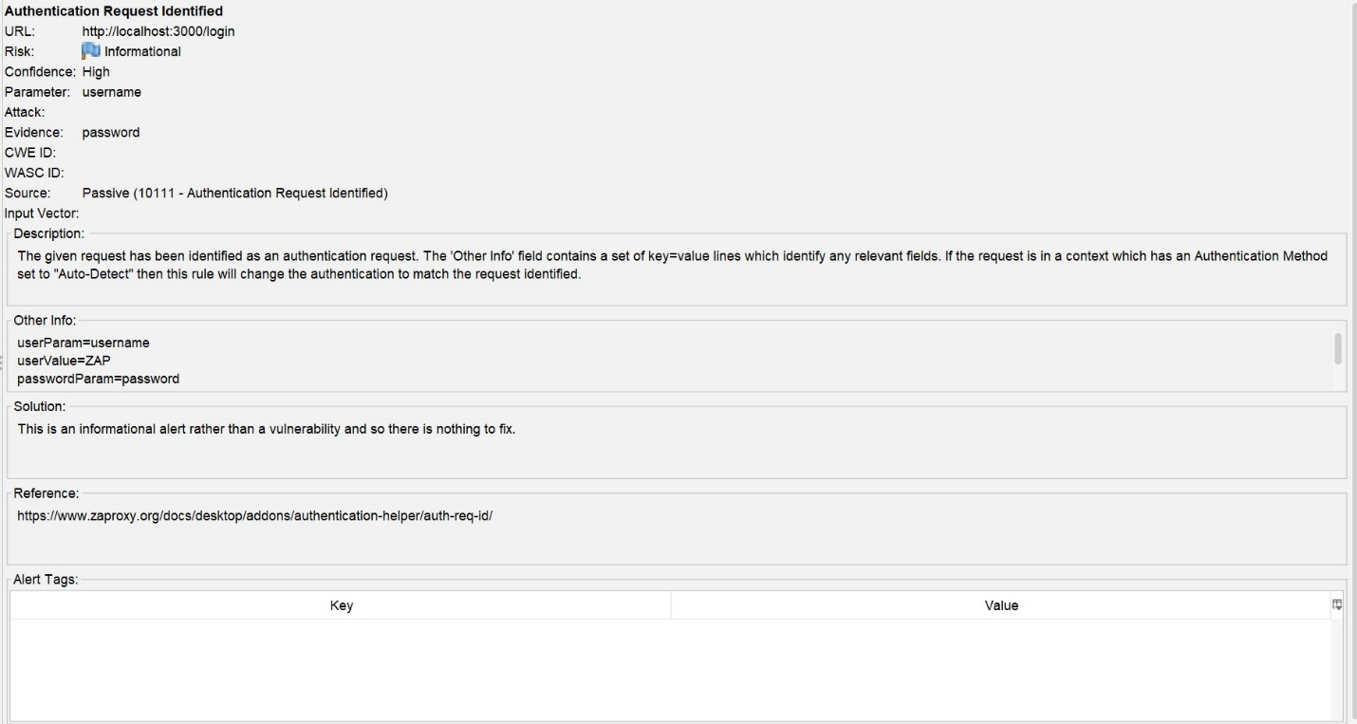
Figure 6 – Session Management Response Identified
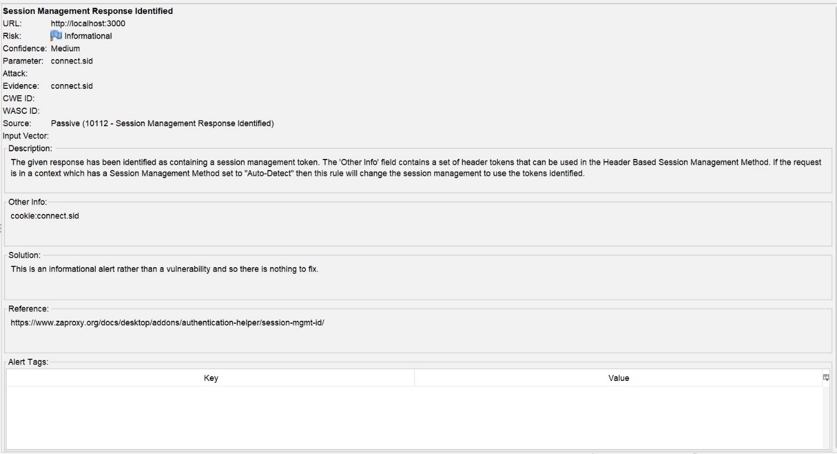
Figure 7 – User Agent Fuzzer
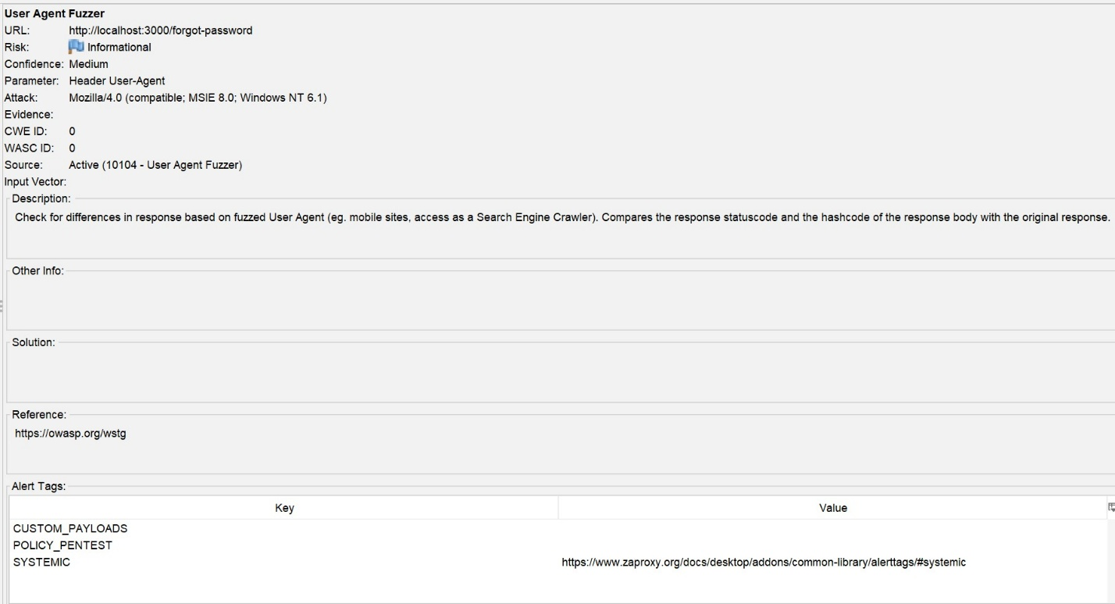
These alerts indicate endpoint discovery and scanning behavior and do not represent security weaknesses.

4. Security Hardening and Revalidation
After reviewing the initial results, the Content Security Policy configuration was tightened to remove the wildcard directive and reduce overly permissive allowances.
The automated scan was then executed a second time to validate improvements.
Figure 8 – Second OWASP ZAP Alert Summary After CSP Hardening
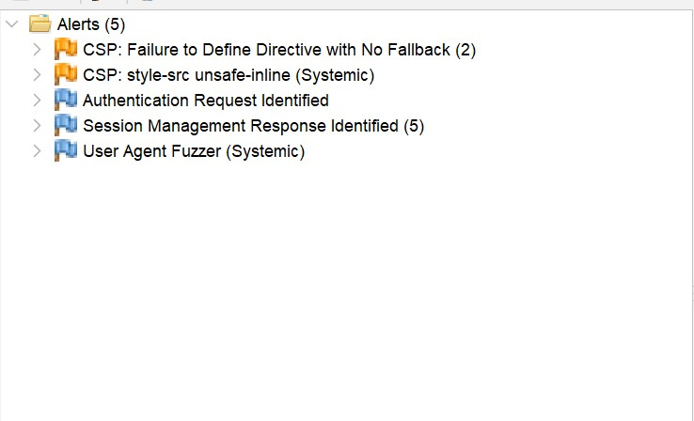
The second scan confirmed:
- The CSP Wildcard Directive finding was eliminated.
- No High Risk vulnerabilities were detected.
- Remaining alerts were limited to non-critical CSP hardening recommendations and informational findings.
This demonstrates measurable improvement in the application’s security posture following configuration refinement.

5. Validation of Previously Exploited Vulnerabilities
The automated scan did not detect:
- NoSQL injection vulnerabilities
- Stored or reflected XSS
- Authentication bypass
- Missing CSRF protections
- Insecure session cookie configuration
This confirms that vulnerabilities demonstrated during Week 5 controlled attack testing are no longer detectable through automated scanning.
Combined with manual validation conducted in Week 7, this establishes strong evidence of successful remediation.

6. Security Posture Comparison
Category | Vulnerable State (Week 5) | Secure State (Week 8)
NoSQL Injection | Exploitable | Not Detected
Stored XSS | Executable | Blocked
Account Enumeration | Possible | Prevented
Session Cookie Security | HttpOnly disabled | HttpOnly + SameSite
CSRF Protection | Absent | Enforced
CSP Wildcard | Present | Removed
Automated Scan Risk | Multiple weaknesses | 0 High Risk Findings

7. Conclusion
The OWASP ZAP automated validation confirms that the remediated Capstone web application no longer exposes the critical vulnerabilities intentionally introduced during earlier project phases.
All previously demonstrated attack vectors including NoSQL injection, stored XSS, account enumeration, and insecure session handling, were successfully mitigated. Automated scanning produced no High Risk findings, and remaining alerts were limited to configuration-level recommendations rather than exploitable flaws.
The measurable reduction in findings between scans further demonstrates effective security hardening and alignment with OWASP Top 10 best practices.
The application now reflects a secure baseline configuration supported by layered defensive controls and validated remediation.

AI Assistance Disclosure
Portions of this document were structured and refined with the assistance of AI (ChatGPT). All scanning, configuration, remediation, and validation activities were performed by the student.

